Name: Karan R
Domain: Data Analyst
Project: Power BI Snapdeal Project
Task 5: Assume you added a column Scraping date. How would you create a visualization in power BI to track average discount trend over time? Which chart type would you choose and why?

Answer:
To analyze how discounts change over time, a Line chart was used with Scraped Date as the time dimension and Average Discount (%) as the measure.

Explanation:
The line chart displays Scraped Date on the X-axis and Average Discount (%) on the Y-axis, where each point represents the average discount calculated for a specific data collection timestamp. This visualization allows continuous tracking of discount behavior across different scraping times.
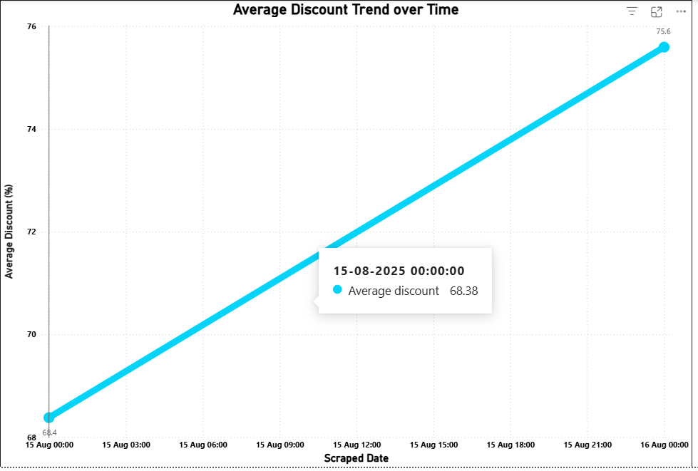
From the chart, an upward trend in average discount is observed over the scraping period. The average discount increases steadily form approximately 68% to 75%, indicating that discount levels became more aggressive in later scraping intervals. The smooth line indicates a consistent change rather than spikes, suggesting planned promotional activity rather than random discount fluctuations.

Interpretation:
The increasing trend implies that sellers may be offering higher discounts over time, possibly due to ongoing promotions, inventory clearance strategies, or competitive pricing adjustments. Since the dataset reflects limited scraping timestamps, the trend represents snapshot-based changes rather than long-term seasonal behavior.

Conclusion:
Using a line chart to track average discount over time provides a clear and intuitive view of promotional trends. This approach enables stakeholders to monitor pricing strategies, identify changes in discount intensity, and support data-driven decision-making in an e-commerce environment.

